**UML**

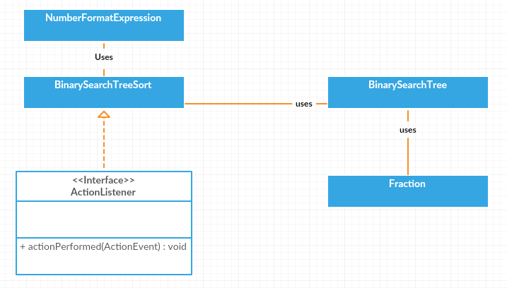

**Test Case:**

1. When no data is entered

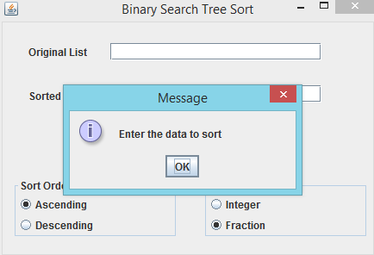

b) When no sorting option is selected

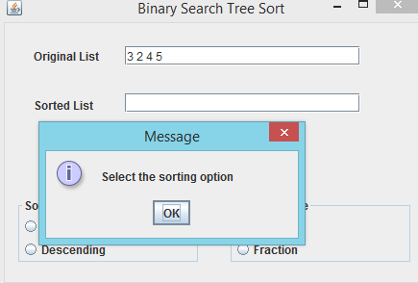

C ) When no numeric type is selected

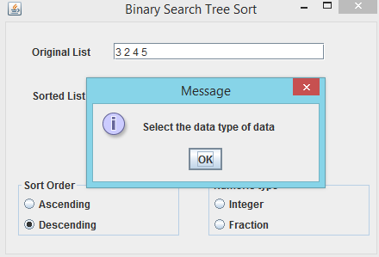

d) Sort the Integer data in ascending order

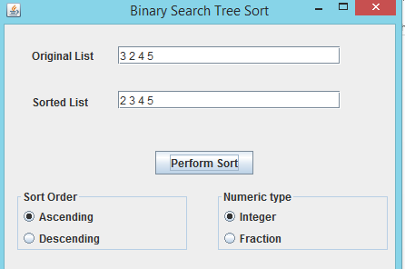

e) Sort the Integer data in descending order

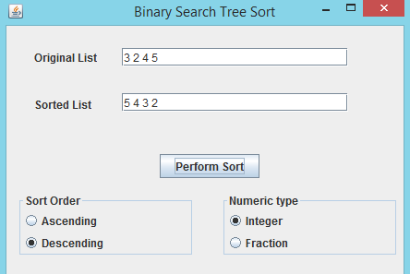

g) Sort the fraction data in ascending order

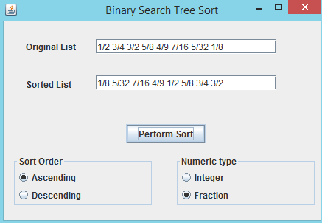

h) Sort the fraction data in descending order

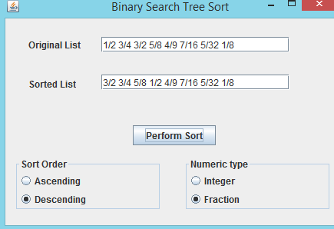

Insert the non-numeric data

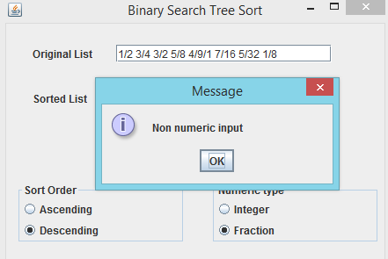

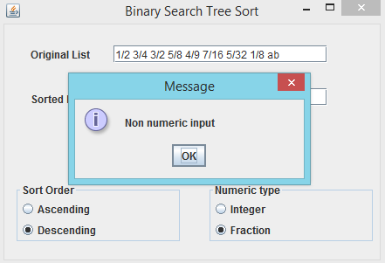

**Lesson Learned:**

The following things are learnt via the assignment:

1. Use of Java Swing framework like JFrame, JPanel, JTextField, JLabel etc.
2. Event Handling
3. Implementation of Binary Search Tree
4. Use of Generic Classes
5. TypeCasting of Classes